FT-100 Display Icon Summary | YAESU USA
This document shows the various display icons used in the Yaesu FT-100 transceiver. Included is a brief description of each icon, and where applicable, the corresponding page number of the FT-100 Operating Manual where more detailed information can be found.

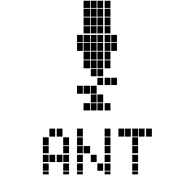 | 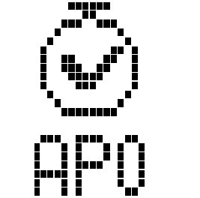 | 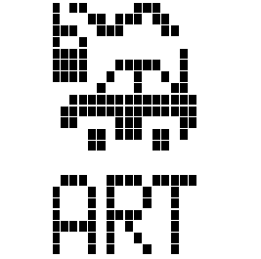 | 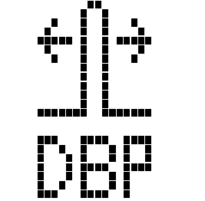 | 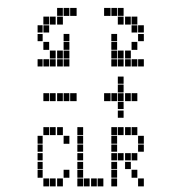 | 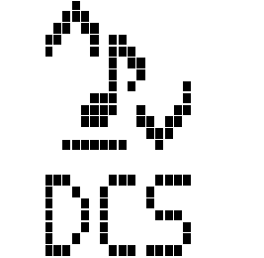 | 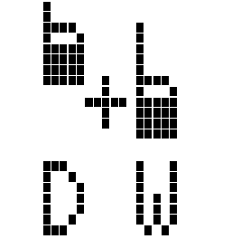 | 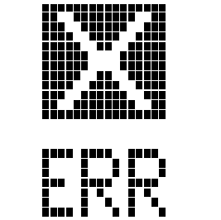 | 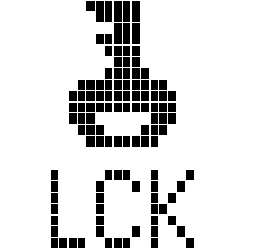 | 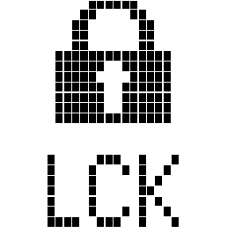
ATAS-100 is Tuning  Page 64 | Auto. Power Off is active  Page 46 | ARTS Mode is active  Page 58 | DSP Band Pass Fil.Active  Page 44 | Clarifier (RIT) is Active  Page 39 | Digital Coded Squelch On  Page 56 | Dual-Watch Scan is active  Page 81 | Non-specific Error Message | Dial is Locked (AM/FM Click)  Page 46 | Dial & Panel Locked  Page 38

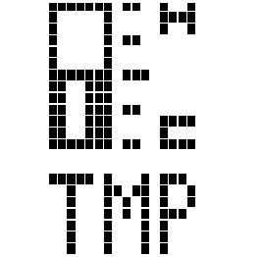 | 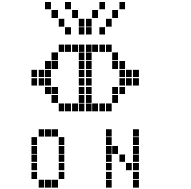 | 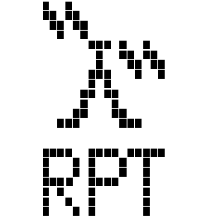 | 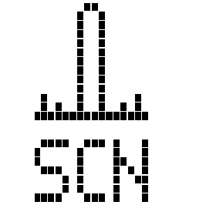 | 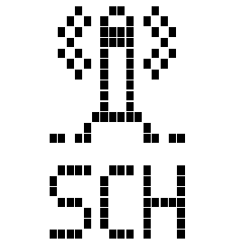 | 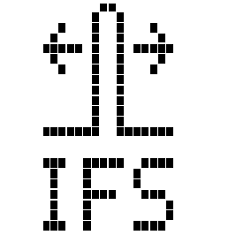 | 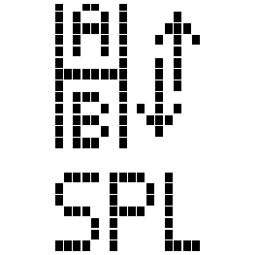 | 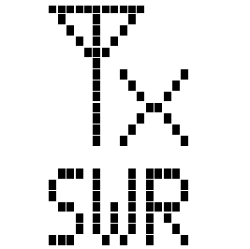 | 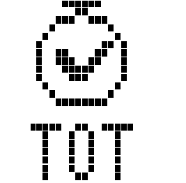 | 
High Temperature  Warning (1) | Power-up Initialization | FM Repeater Mode Active  Page 54 | Scan mode Active  Page 78 | VFO Smart-Search Active  Page 77 | IF Shift Control Active  Page 42 | Split mode Active  Page 59 | High SWR Warning (1) | TX Time-Out Time Reached  Page 59 | FC-20 tuner is tuning  Page 68

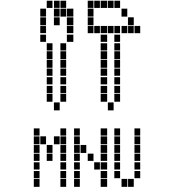 | 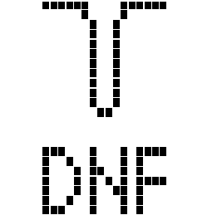 | 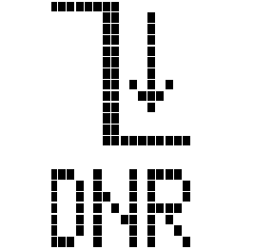 | 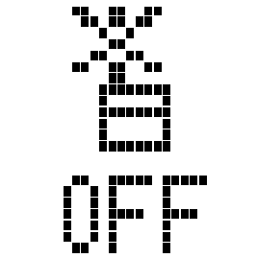 | - Continued use of the FT-100 while the Temperature or SWR Icon is shown may damage the transceiver.  - This icon indicates that the selected transmitter frequency is invalid. No RF output is produced during this condition.  Rev 1: 11/4/99MK
Setting Menu Active  Page 82 | DSP Notch Filter  Page 45 | DSP Noise Reduction On  Page 45 | TX Inhibit (2)

